Class 4 – Global Energy Transition

Instructor: Nate Tucker

Date: 20-Feb-2021

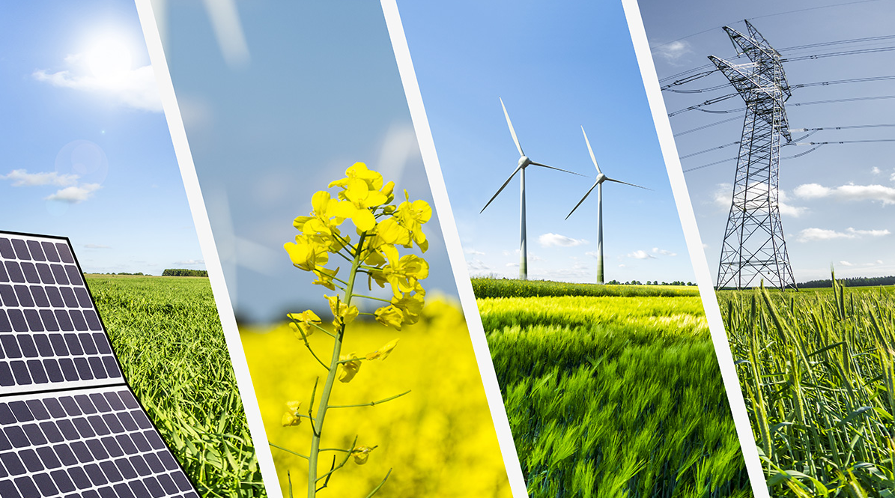

# About Us:

* Nate Tucker – Instructor
  + One fun thing you did over the last 2 weeks:
* Ramsay Birkhahn
  + One fun thing you did over the last 2 weeks:
* Caroline Keohane
  + One fun thing you did over the last 2 weeks:
* Alexa Nares
  + One fun thing you did over the last 2 weeks:
* Erika Nares
  + One fun thing you did over the last 2 weeks:
* Karla Medrano
  + One fun thing you did over the last 2 weeks:
* Carlos Valencia
  + One fun thing you did over the last 2 weeks:
* Diego Ramirez
  + One fun thing you did over the last 2 weeks:
* Catalina Gallardo
  + One fun thing you did over the last 2 weeks:
* Rowen Manriquez
  + One fun thing you did over the last 2 weeks:
* Abigail Marin Iniestra
  + One fun thing you did over the last 2 weeks:

# Course Overview:

* 5 Saturday Meetings - Discussion oriented
  + Intro to Energy
  + Conventional Energy Sources (coal, natural gas, petroleum)
  + Renewable Energy Sources (solar, wind, geothermal, hydro)
  + Upcoming Technologies, Future Goals, Industry Shifts
  + Sustainability in our lives

# Feedback from Classes 1,2,3

* What we learned from class 1:
  + Many types of energy
  + Our society is inefficient, we waste a lot of energy
  + “Sustainable” technologies depend on their energy source
  + Articles about energy can be biased
* What we learned from class 2:
  + Limited supply of coal and oil in the world
  + Coal and oil are transported across the world for use
  + Oil can have some negative effects on the environment if not handled correctly
  + Coal and oil have been used as energy resources for a long time
  + Coal – mainly used for generating electricity (steam plant)
  + Oil – mainly used for transportation (i.e., refined into gasoline, diesel, etc.)
* What we learned from class 3:
  + Learned about solar towers that use mirrors to reflect sunlight to heat up molten salt to create steam
  + Learned about wind, solar, hydro, and geothermal renewable energy resources
  + Learned there are pros and cons to each renewable energy source
* Goals for today
  + Discuss current trends and the future
    - CO2 emissions

# Investigation – Carbon Mitigation

* Objectives:
  + Evaluate the growth of carbon emissions over time at the global scale
  + Compare current rate of emissions with past rates of emissions
  + Identify actions that can help to curb the rate of carbon emissions
  + Analyze costs and benefits associated with different emissions reductions actions
  + Select a set of actions intended to reduce carbon emissions at the global scale
  + Debate and defend the selected actions based on research
* Energy and Climate Change
  + The hydrocarbons found in fossil fuels provide the energy content to power most of our homes, businesses, industries, and vehicles
  + When burned, these fossil fuels also release carbon dioxide (CO2) and other gases which contribute to global climate change
  + Global climate change is already beginning to impact the earth’s natural ecosystems, agriculture, world economies, and our human-built environments
* Basic Climate Change Science
  + The science behind climate change can be complex, but at its most basic chemical level can be widely understood.
  + Nearly all the air in our atmosphere is made of nitrogen (N2) and oxygen (O2), in which two atoms of the same element share electrons. Heat radiated up from the surface of the earth can be absorbed by these molecules. But because these are “diatomic” molecules that are limited in the ways they can vibrate and shift, they can’t trap heat particularly well.

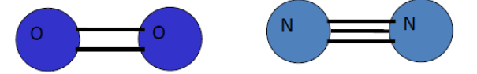

* Carbon dioxide (CO2) and water vapor (H20) are slightly more complex molecules that have more ways to maneuver and therefore are better at trapping heat as it tries to pass through them.

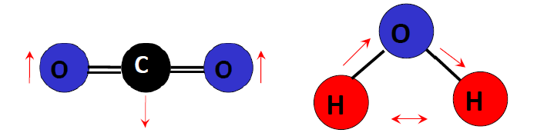

* So, when we add carbon dioxide to our atmosphere, the atmosphere traps more heat and the average temperature of the earth rises. This science is not new – John Tyndall actually measured the absorption capacity of CO2 back in 1863!
* Global Overview
  + Are global levels of CO2 rising and is this rise caused by humans?
    - YES and YES
  + The chart below shows that over the past 420,000 years, CO2 in the atmosphere has varied between 180 and 280 parts per million (ppm), rising and falling within the last four glacial cycles.
  + Since the industrial revolution, CO2 has risen very rapidly and as of 2010 was measured at 390 ppm
  + Climate experts believe that with a continued rise in CO2 levels, the earth can experience average temperature rises between 2 and 5 degrees Celsius (3.6 to 9 degrees Fahrenheit).
  + In the arctic, the temperature rise is predicted to be 8-14 degrees F
  + In North America, the temperature rise is predicted to be 5-11 degrees F

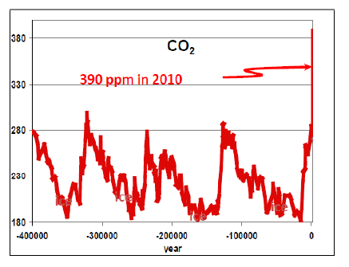

* Solutions
  + In California and across the globe, CO2 emissions are expected to continue rising
  + The Carbon Mitigation Initiative (CMI) at Princeton University has analyzed what it would take to slow our emissions so that the level of emissions in 2055 is no greater than what we emitted in 2005.
  + This wouldn’t stop global climate change due to human activity, but it would be a start.

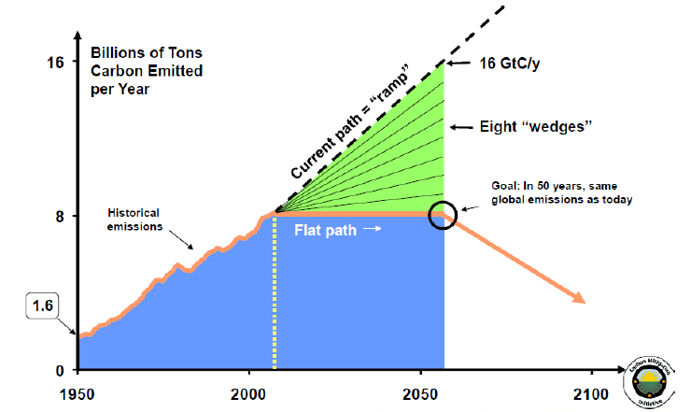

* The triangle in green represents the difference between our current path of global carbon emissions and a “flat” path of no increases in emissions over the next 50 years. That triangle is sometimes referred to as the “stabilization triangle”.
* By 2055, the difference between the current path and the flat path is 8 billion tons of carbon emissions per year.
* The stabilization triangle can then be broken down into eight slices, or “wedges”, that each represent 1 billion tons of carbon emissions avoided per year.
* The CMI went further and identified a number of actions we could take by 2055 that are already commercially viable and that would result in 1 wedge (1 billion tons) of carbon avoided, including:

• Doubling the fuel efficiency of the world’s cars

• Substituting 1,400 natural gas electric plants for an equal number of coal-fired plants

• Tripling the world’s nuclear capacity

• Installing 1 million two MW (megawatt) wind turbines to replace coal electricity

• Installing 20,000 square kilometers (7,700 square miles) – an area almost the size of New Jersey – worth of solar panels to replace coal electricity

• Eliminating all tropical deforestation

• Using conservation tillage on all cropland in the world

* **Wedge activity** 
  + Class 4 – Wedge pdf file on Gauchospace
  + 10-15 minutes to read all the different ways to cut carbon
  + Select 8 of the 15 methods as humanity’s plan to cut carbon
    - Be ready to describe and defend your choices!
* Engagement:
  + What do you think about global climate change?
  + Do you think climate change is a serious problem?
  + Do you think we can take actions to mitigate climate change?
  + What are the difficulties associated with taking action on climate change?
* Elaboration
  + What are the challenges we face in curbing global climate change?
  + What opportunities are most “ripe” for reducing carbon emissions?
  + How might different stakeholders view various strategies?
  + Are some strategies likely to be more widely accepted than others? Why or why not?
  + Industrialized countries and developing countries now contribute each about half the world’s emissions, although the poorer countries have about 85% of the world’s population (The US alone emits one fought of the world’s CO2). If we agree to freeze global emissions at current levels, that means if emissions in one region of the world go up as a result of economic/industrial development, then emissions must be cut elsewhere. Should the “richer” countries reduce their emissions 50 years from now so that extra carbon emissions can be available to the developing countries?
  + Nuclear energy is already providing one-half wedge of emissions savings – what do you think the future of these plants should be?

# Exit Survey

<https://forms.gle/DTr42hCioV5TR7kw7>